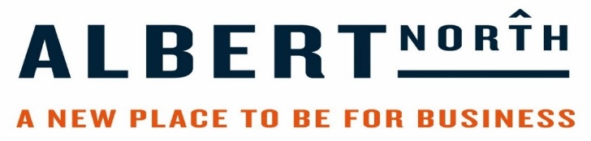

Business | Offer
Alkaline Kitchen | 10% off food & drink
Ananda Wellbeing Studio | 10% off classes & membership
Pie Jackers | 10% off when eating in on Mondays & Tuesdays
Al Forno's | Two for one (any pizza/pasta from ala carte menu) Cheapest one free  *offer not valid 1st to 31st December  *offer valid in Middlesbrough Restaurant only  *offer available between 12pm and 6pm
TP Coffee House | 10% off per minimum spend of £4 and have a loyalty card for  the purchase of which will buy 10 hot drinks and get one free.
Umi Japenese | 10% of the food bill when total exceeds £20.
Elianos | 10% off Food from Al A Carte menu (excludes any other offers or promotions on the menu) Please mention Albert Road North Loyalty card when making booking.
Mannequin Café | Loyalty card for hot drinks  afternoon treat, coffee and cake for £3.90  Breakfast bun w/tea/white coffee/black coffee £3.00
Turtlebay | 20% Discount of food bill (when a drink is purchased) Sunday - Friday. Excludes set menus (inc. Christmas)
La Pharmacie | 10% of Food Bill - does not apply to the £5 menu
Peri Peri Original | 10% of A-F meals on the menu
Uno Ristorante | 10% Discount
Boho Bytes café | loyalty card scheme for drinks and specials
Pierre | 10% of ladies and gents hair. 15% of Spray Tans
Little Vegan Market | 10% off on zero waste products. 15% if you bring your own container
Manjaros | 15% of Food Bill when dining Mon-Thurs 12-5pm
The Nesting Box | Tuesdays and Fridays 20% of Everything (excluding facial treatments)
UltraChique Salon | 10% of all spa, beauty and clinic therapies. Full priced items only
Dovecot | 20% of all Food Purchases between 12-2pm
Oodles Noodles | 10% discount on take away and sit in meals- Linthorpe Road
Holiday Inn Express | 15% off bedroom & 20% off food and beverage during stay
The Stottie Company | 20% off any purchase between Monday 7th January and Sunday 20th January then 10% any purchase.  Restrictions; not including alcohol sales

